Swedish pension fiche prepared for the AWG projections for age-related public expenditure 2011
Memorandum
5 January 2012
Ministry of Finance
Sweden
Economic affairs department
Olle Sundberg
E-mail olle.sundberg@finance.ministry.se
Jonas Norlin

Sweden – The pension system and pension projections until 2060

1. Overview of the pension system
The Swedish public old-age pension system consists of an earnings-related component based on notional accounts, a private mandatory defined contribution system and a pension-income-tested top-up, the guarantee pension. Most employees are covered by occupational pension plans. It is also possible to make tax-deductions for private pension savings.

1.1 The Swedish public pension system
The new Swedish public old-age pension system was fully implemented in 2003. The new earnings-related old-age pension system consists of a notionally defined contribution (NDC) PAYG component and a fully funded, defined contribution (DC) pension system. Both are based on lifetime earnings and individual accounts. In addition, there is a pension-income-tested top up, the guarantee pension, which is financed with general taxes from the central government budget. The same rules apply to all persons regardless of occupational sector and for employees and self-employed alike. The former Swedish pension system consisted of a flat-rate pension provided in full to everyone with at least 40 years of residence in Sweden between the ages of 16 and 65. Further, it included an earnings-related pay-as-you-go (PAYG) component providing a benefit based on 60 per cent of an average of the contributors best 15 years of earnings, with 30 years required to receive a full benefit.
The new system covers individuals born 1938 and later, with transition rules for persons born 1938-1953. Given the actual pension pattern, the last cohorts with pension rights in the old system will retire around 2020. As a result, it will take a couple of decades until all beneficiaries have all of their benefits calculated according to the new rules. Pension rights are credited to the individual accounts for 18.5 percent of the annual pensionable income up to the pension ceiling amounting to 8.07 income base amounts. 16 percentage points are paid to the NDC PAYG system and 2.5 percentage points to the funded DC system. The insured pay a pension contribution amounting to 7 percent of the gross pensionable income, and the employer 10.21 per cent. Contributions over the pension ceiling is transferred to the central government budget as general tax and has no connection to the income-based pension system. Contributions are also paid by the central government to cover pension entitlements credited for income replacement social insurances, e.g. for unemployment, sickness, disability or parental leave.
The retirement age is flexible and individuals can claim benefits from the age of 61 without any upper limit. Under the Employment Protection Act, an employee is entitled to stay in employment until his/her 67th birthday.

Table 1 – Statutory retirement age, earliest retirement age and penalties for early retirement

Men and women |  | 2010 | 2020 | 2030 | 2040 | 2050 | 2060
- with 20 contribution years | statutory retirement age | No limit
- with 20 contribution years | earliest retirement age  (Guarantee pension) | 61  (65) | 61  (65) | 61  (65) | 61  (65) | 61  (65) | 61  (65)
- with 20 contribution years | penalty in case of earliest retirement age | Actuarial adjustment
- with 40 contribution years | statutory retirement age | No limit
- with 40 contribution years | earliest retirement age  (Guarantee pension) | 61  (65) | 61  (65) | 61  (65) | 61  (65) | 61  (65) | 61  (65)
- with 40 contribution years | penalty in case of earliest retirement age | Actuarial adjustment
Note: Transitional rules apply for individual born before 1953.
Source: Ministry of Finance

The DC PAYG system
The NDC PAYG pension system works on an actuarial basis. At the time of retirement an annuity is calculated by dividing the individual’s account value by a divisor reflecting unisex life expectancy at the specific date of retirement. The individual can counteract the negative effect on the annuity caused by increasing life expectancy by postponing the date of retirement, thus giving strong incentives to prolong the working career. If an individual born in 1946 delays the retirement from 65 to 67 the annuity divisor decreases from 16.31 to 15.16 and the NDC pension consequently increases with 7.6 %.
The PAYG-pensions in payment is on average indexed by wages, but is front-loaded in the sense that and the pensioners receive a share of the real economic growth in advance. The NDC savings is as a primary rule indexed by the average rate of growth of earnings per contributor. In case of financial sustainability problems though, the automatic balancing mechanism is activated and the indexation reduced until the stability is restored. This secures that the system will be able to finance its obligations with a fixed contribution rate and fixed rules regardless of the demographic or economic development. The balancing indexation was activated for the first time in 2010 because of the financial crisis in 2008. More details about the automatic balancing can be found in appendix 1 and 2.

Non-earnings-related minimum pensions and basic security
The pension-income-tested top-up, the Guarantee pension, is financed by general tax revenues. The benefit is proportionally reduced if the number of residence years in Sweden falls short of 40. The guarantee pension together with the means-tested housing supplement for pensioners is higher than the minimum income standard in the system for social assistance. All forms of basic security benefits for the elderly can be received from the age of 65, not earlier. The guarantee pension is price indexed and fully taxed.
The guarantee pension is means-tested against public pension income and survivor benefits, but not against work income etc. For low incomes the benefit is reduced krona by krona, and for higher incomes the benefit is reduced by 48 per cent. The annual benefit amounts to maximum 2.13 price base amounts (PBA) (EUR 9 600 year 2011) for single households and 1.90 PBA:s per person (EUR 8 500 year 2011) for cohabitants. The guarantee pension is fully phased out when the income pension reaches 3.07 PBA:s for single households and 2.72 PBA:s for cohabitants.
Formally outside the old-age pension system, but de facto closely interlinked, there is the tax-free means tested Housing supplement for pensioners (BTP). There is also a Special housing supplement (SBTP) for pensioners with low income and high housing costs. Finally there is a tax-free means-tested program, Maintenance support for the elderly (ÄFS), which ensure that pensioners with very low income, usually immigrants with few years of residence in Sweden, not become dependent on social assistance. The size depends on household income and housing costs, but is by design always higher than the social assistance benefit.

Early retirement, disability and survivor’s pension
It is possible to retire at the age of 61 in the new pension system, but the loss is twofold for the individual. First, the benefit is based upon lifetime contributions, which implies that all years with earnings are important. Second, the level of the benefit is calculated in proportion to cohort-specific life expectancy from the date of retirement. Leaving early implies a lower (notional) pension capital and a longer period for payments and therefore the benefit will be lower per annum compared with a later retirement age. Regardless of the flexibility in the new pension system there is a strong tendency in the society to claim public pension at age 65 that was the norm in the old system. However, to claim pension is not the same as leaving the labour market. In year 2010 the average age for withdrawal from the labour market was estimated to age 63.1.
The reformed pension system is individual-based. The previous widow’s pension has been replaced by a new, temporary and gender-neutral, so-called adjustment allowance. However, due to the long transition period, widow’s pensions will continue to be paid out for several decades. In the new system, a survivor will receive adjustment allowance for 12 months as a standard, but the payments continue as long as the survivor has children younger than 12 years. The size of the adjustment allowance as well as the widow’s pension is based upon the deceased’s earnings.
Disability benefits, which are equivalent to disability pensions in most European countries, are formally a part of the sickness insurance scheme. Also individuals with disability benefits accumulate pension entitlements in the public pension system. Contributions are paid by the central government budget. Public old-age pension benefits for disabled persons, as for everyone else, are based on lifetime earnings.

1.2 Occupational pensions
The main part of all employees, both in the public and the private sector, are covered by occupational pension plans based on collective agreements between the unions and the employers’ confederations. Membership in the schemes is semi-mandatory for all employers and employees working in an industry covered by such an agreement. The collective agreements include occupational pension schemes financed through employers’ contributions, which provide pension as supplement to the public system, but also pension compensation for incomes above the public system pension ceiling. Thus, these schemes are most important for high-income earners. There are four major occupational plans: blue-collar workers in the private sector, white-collar workers in the private sector, central government employees and local government employees.

1.3 Private pensions
Mandatory private premium pension
The public system also consists of a private mandatory fully funded defined-contribution part, the Premium pension. The system is administered by the state and financed by a contribution rate of 2.5% of pensionable earnings, following the same transition rules as the PAYG system. Individuals choose from a large number of mutual funds, how to invest their contributions. The individual mutual funds earn a market rate of return. At retirement, at any age from 61 years, individuals can choose a fixed or variable annuity, in part or in full.

Voluntary private pensions
It is also possible to make tax-deductions for private pension saving, something that is especially important for self-employed who not are covered by any occupational pension plans. Since 2008 the maximum yearly deduction allowed is SEK 12 000 (EUR 1 260). For self-employed not eligible to occupational saving plans higher deductions apply. In 2009 approximately 39 per cent of the population 20-64 years made tax-deductions for private pension savings, in average SEK 5 400 (EUR 570) and in total SEK 10 700 billion (EUR 1 120 billion).

1.4 Tax status
Old-age (including guarantee pension), disability and survivors pension, is subject to income tax (but not payroll taxes). The means-tested basic security allowances (BTP, SBTP and ÄFS) are tax-free. Private tax-deductible pension savings as well as funded occupational pensions are taxed ETT (contributions Exempt, returns Taxed, benefits Taxed). The mandatory premium pension is taxed EET.

1.5 Recent reforms of the public pension system included in the projections
There has been no reform within the old age pension system since 2003, except for minor modifications in the formula for calculation of the balancing index. Due to the turbulence in the markets during the financial crisis that started in 2008 it was decided to smooth the value of the funds in order to make the system more robust. However, this change only affects the system in the short run, and not at all when the automatic balancing is not engaged. More information about the automatic balancing can be found in appendix 1 and 2.
In order to strengthen the economy for the elderly, in particular low-income pensioners, a new special basic tax deduction for individuals 65+ was introduced in 2009, and then increased in steps 2010 and 2011. In addition, the Earned Income Tax Credit (EITC) that was introduced in 2007 makes work pay better for everyone, especially pensioners. For individuals 65+ the EITC is approximately doubled, giving strong incentives for elderly to prolong their working lives. Social contributions (31.42% of earnings in 2011) has been reduced for elderly and individuals 65+ only pays the old age pension contribution (10,21% of the earnings).
In order to get the increasing costs for the disability pension under control the system has been reformed. The changes primarily deal with stricter eligibility conditions that require permanent reduction of the ability to work, thus reducing the inflow of retirees. Already granted benefits remain the same, with exception of the temporary disability pension that has been abolished and is being phased out until 2013.
In 2011, an investigation was launched with the aim to take a comprehensive approach to the question of what can be done to make us work longer. The Committee's tasks include reviewing pension-related age limits and the obstacles and opportunities that exist for elderly to stay in work. In addition, the inquiry has the task to give proposals on how the pension-related age limits should be handled and to develop proposals how to enhance the work environment and provide better conditions to work longer into old age.

1.6 Description of the actual "constant policy" assumptions used in the projection
All types of pensions, benefits and thresholds are assumed income indexed from 2015 in the calculations, regardless if legislation states otherwise (e.g. guarantee pension, BTP, SBPT and ÄFS are price indexed by law). In addition, all thresholds in the tax system are income indexed.

2. Projection results

2.1 Extent of the coverage of the pension schemes in the projections
The projections include the public income pension and the means tested guarantee pension, as well as disability and survivor’s pensions. The calculations also include occupational and private pension schemes. Also Housing supplement for pensioners etc. is included. Apart from the population living in Sweden, the calculations cover individuals with Swedish pension rights living abroad.

There are some differences between the ESSPROS data presented by Eurostat and the data used by AWG, see table 2. First, there is a small difference between the public ESSPROS data presented by Eurostat and the numbers presented by Statistics Sweden. Secondly, there are differences between the ESSPROS numbers from Statistics Sweden and the definition used in the AWG calculations. The AWG numbers exclude the work injury benefit and some minor benefits for handicapped, but include the housing supplement for the elderly and disabled. The excluded and extra items are of the same magnitude and the GDP-ratio for the public expenditures remains 9.5 percentage points in 2008.

Table 2 - Eurostat (ESSPROS) vs. Ageing Working Group definition of pension expenditure (% GDP)
 | 2003 | 2004 | 2005 | 2006 | 2007 | 2008 | 2009 | 2010
1 Eurostat total pension expenditure | 12,2 | 12,2 | 12,2 | 11,8 | 11,6 | 11,8 | : | :
1.b Statistics Sweden ESSPROS |  | 12.4 | 12.4 | 12.0 | 11.7 | 12.0 | 13.2
2 Eurostat public pension expenditure | 9,9 | 9,9 | 9,8 | 9,4 | 9,2 | 9,3 | : | :
2.b Statistics Sweden public ESSPROS |  |  |  |  |  | 9.5
4.b Difference 2 – 2.b |  |  |  |  |  | -0,2
3 Public pension expenditure (AWG) | 10,1 | 10,1 | 10,0 | 9,6 | 9,3 | 9,5 | 10,4 | 9,6
4 Difference (2) - (3) | -0,2 | -0,2 | -0,2 | -0,2 | -0,2 | -0,2 | : | :
5 Expenditure categories not considered in the AWG definition
5.1 Work injury benefit |  |  |  |  |  | - 0.2
5.2 Economic integration of the  handicapped and Care allowance |  |  |  |  |  | - 0.2
6 Expenditure categories considered in the AWG definition, but not in ESSPROS as cash benefits
6.1 Housing supplement for  elderly and disabled |  |  |  |  |  | 0.4
Source: Eurostat, Statistics Sweden and Ministry of Finance

2.2 Overview of the projection results
Projected gross public pension spending as a percentage of GDP will end up at 10.2 % in 2060 in the baseline scenario, an increase with 0.6 percentage points compared to the starting year 2010. The moderate growth of the public pensions is partly explained by the growing importance of the premium pension. The system will grow in importance throughout the whole period until 2060 as the system is gradually maturing, and thus the public part of total pension expenditure is projected to decrease. Other factors that mitigate the increase are the phasing out of the widows pension, and the reform of the disability pension.
The importance of occupational pensions will grow. The reason is that the coverage, mainly as a result of increased participation rate for women until 1995, results in a higher expenditure to GDP ratio until approximately 2030. After 2030 the share will stabilize and the effect of the ageing population will dominate.

Table 3 - Projected gross and net pension spending and contributions (% of GDP)
Expenditure | 2005 | 2010 | 2020 | 2030 | 2040 | 2050 | 2060 | Peak year*
Gross public pension expenditures | 10,0 | 9,6 | 9,6 | 10,1 | 10,2 | 9,9 | 10,2 | 2059
Occupational pensions | 1,3 | 1,5 | 2,1 | 2,6 | 2,7 | 2,6 | 2,8 | 2059
Private pensions | 0,0 | 0,0 | 0,3 | 0,6 | 1,1 | 1,3 | 1,5 | 2060
Mandatory private (premium pension) | 0,0 | 0,0 | 0,3 | 0,6 | 1,1 | 1,3 | 1,5 | 2060
Non-mandatory private | : | : | : | : | : | : | : | :
Net public pension expenditure | 7,2 | 7,0 | 7,0 | 7,3 | 7,4 | 7,2 | 7,4 | 2035
Net total pension expenditure | 8,1 | 8,1 | 8,7 | 9,7 | 10,1 | 9,9 | 10,5 | 2059
Contributions | 2000 | 2010 | 2020 | 2030 | 2040 | 2050 | 2060 | Peak year*
Public pension contributions (NDC system) | 7,1 | 7,2 | 7,4 | 7,5 | 7,5 | 7,5 | 7,5 | 2052:
Total pension contributions | 8,8 | 9,1 | 9,4 | 9,5 | 9,5 | 9,6 | 9,5 | 2052
Note: The peak year is the year in which the particular variable reaches its maximum over the projection period 2010 to 2060.

Pensions are taxed in the same way as other income. Thus, it is not possible to sort out the tax on different types of pension income. The average implicit tax rate on pension income will remain more or less constant until 2060. Due to the introduction of the EITC in 2007 it will be more favourable to work, especially for individuals aged 65+.
The earnings–related pensions will increase somewhat until 2018, and then start to decrease. This is the result of the pension reform that gradually transforms the old DB system into the new NDC system. In the old DB system the effect of the growing female labour participation had a faster impact on the pensions, as the benefits in the old system depend on the 15 best out of 30 years, and not throughout the whole career as in new NDC system.

Minimum pensions
The importance of the minimum top-up guarantee pension (including the housing supplement) will grow from 0,8 %/GDP to 2.6%/GDP, as a result of decreasing replacement rate from earnings-related pensions, which in turn is the result of that the longevity is growing faster than the retirement age. Note that the guarantee pension is indexed with average earnings in the calculations from 2015, but price indexed in the legislation. Since the new rules entered into force in 2003, no changes of the parameters in the guarantee pension system has been done. The assumption about income indexation might therefore be too cautious.

Table 4 - Projected gross public pension spending by scheme (% of GDP)
Pension scheme | 2005 | 2010 | 2020 | 2030 | 2040 | 2050 | 2060 | Peak year *
Total public pensions | 10,0 | 9,6 | 9,6 | 10,1 | 10,2 | 9,9 | 10,2 | 2059
of which
Old age and early  pensions | 7,2 | 7,5 | 8,3 | 8,7 | 8,8 | 8,6 | 9,2 | 2060
of which
Earnings-related | 6.1 | 6.7 | 7.2 | 7.1 | 6.8 | 6.3 | 6.6 | 2018
Non-earnings-related minimum pensions | 1.1 | 0.8 | 1.0 | 1.6 | 2.0 | 2.3 | 2.6 | 2060
Disability pensions | 2,2 | 1,7 | 1,0 | 1,2 | 1,2 | 1,2 | 1,0 | 2010
Survivors | 0,6 | 0,5 | 0,3 | 0,2 | 0,2 | 0,1 | 0,0 | 2010
Note: The peak year is the year in which the particular variable reaches its maximum over the projection period 2010 to 2060.

Disability pension
The cost for the disability pension is projected to decrease because of the reforms implemented since 2007, particularly the stricter eligibility conditions. The number of individual’s with disability pension started to increase sharply in 2003. After a peak of nearly 556 000 individuals in the spring of 2007, the outcome went down to 399 000 in December 2011 as a result of the increased outflow and reduced inflow, i.e. a reduction with 28% from the peak. According to budget forecasts made by the Swedish Social Insurance Agency the number is projected to continue to decline to 289 000 in December 2016, i.e. a further decrease with 28%, all in all a decrease with 48%. In the model calculations a prudent approach has been chosen, as there is a risk that the very low inflow now observed in outcome data and short term projections not will be sustainable. Therefore the inflow to disability pension is aligned to outcome and budget forecasts until 2016. The inflow (as a share of the population at risk) then reverts gradually to the average for the period 2000-2015 during a 10-year period until 2025. The inflow is then kept constant, resulting in an increase of the number of disability pensioners with 14% between 2016 and 2060.

Survivors’ pension
The widow’s pension is being phased out and is replaced by a new, temporary and gender-neutral so-called adjustment allowance. As the old widows pension will be in effect for couples married (or having common children) before 1989, the widow’s pensions will continue to be paid out for several decades. In the end of the projection period, only the small temporary adjustment allowance will be paid out. The benefit is paid out during a 12 month period to surviving spouses younger than 65, mainly to families with children.

2.3 Description of main driving forces
To explain the development of the ratio of pension expenditures to GDP, the growth has been decomposed into its main driving factors according to the equation below:

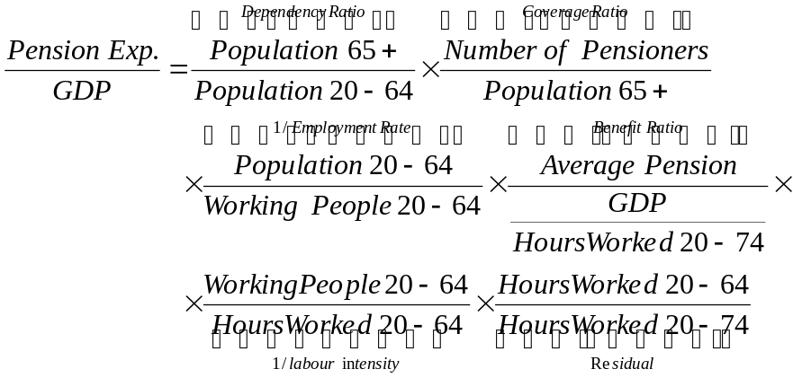 [1]
Note: 'Average pension' = social security pension expenditure divided by the number of pensioners

The demographical change measured by the dependency ratio is the only factor that contributes to the increase of the public pension expenditures. The increase is higher in the beginning of the projection, but is positive for the whole period until 2060. The continued rise of the dependency ratio is due to increased longevity. Also net migration and fertility rates are positive, and working population continues to grow until approximately 2050.
The coverage ratio, the employment effect and the benefit ratio act as offsetting factors counterbalancing the effect of the demography. The coverage ratio will decrease as a result of fewer individuals with pensions younger than 65.
The most striking feature is the decreasing benefit ratio. Several factors contribute to this. The reformed NDC income pension system works on an actuarial basis. At the time of retirement an annuity is calculated by dividing the individual’s account value by a divisor reflecting unisex life expectancy at the specific date of retirement, thus offsetting the effect of the increased longevity. Another important factor is the reclassification of the premium pension from the government to the private sector, which decreases the public benefit ratio, but increases the private. In addition, other factors contribute, e.g. the phasing out of the widows pension.
The employment effect is the result of both increasing participation rate and lower unemployment rate in the beginning and the end of the projection period.

Table 5 - Factors behind the change in public pension expenditures between 2010 and 2060 (in percentage points of GDP)
 | 2010-20 | 2020-30 | 2030-40 | 2040-50 | 2050-60 | 2010-60 | Average annual change
Public pensions to GDP | 0,0 | 0,5 | 0,1 | -0,3 | 0,4 | 0,6 | -0,003
Dependency ratio effect | 1,7 | 1,2 | 0,8 | 0,2 | 1,1 | 5,0 | 0,104
Coverage ratio effect | -0,6 | 0,3 | -0,1 | -0,1 | -0,3 | -0,8 | -0,022
Employment ratio effect | -0,4 | 0,0 | 0,0 | 0,0 | -0,1 | -0,5 | -0,010
Benefit ratio effect | -0,6 | -0,8 | -0,6 | -0,5 | -0,3 | -2,7 | -0,070
Labour intensity effect | 0,0 | 0,0 | 0,0 | 0,0 | 0,0 | 0,0 | 0,000
Residual* | -0,2 | -0,1 | 0,0 | 0,0 | -0,1 | -0,4 | -0,005
Explanatory note: * This residual is made by two components: the residual effect as defined in eq. Equation [1] and the interaction effect.

Evolution of the replacement ratio
The evolution of the replacement ratio, i.e. first pension of those who retire in a given year over an average wage of the economy, is reported in Table 6. The replacement rate from the public pensions will decrease because of the growing longevity that reduces the annuity. As the old system is being phased out, and only the NDC income part of the new system is reported as a public pension, the public replacement rate will decrease significantly. When taking the other part of the new system, into account, the privately classified premium pension, the replacement rate will increase about 7 percentage points. The fast decrease until 2020 is also explained by the fact that the old ATP-system in general where more generous. Individuals that are born after 1953 are entirely in the new system, and thus the old system fully phased out for individuals who retire around 2020. The development will then flatten out, and the development will mainly be driven by the demography and the labour market assumptions.

Table 6 - Replacement rate at retirement (RR) and coverage by pension scheme (in %)
 | 2005 | 2010 | 2020 | 2030 | 2040 | 2050 | 2060
Public scheme (RR) | : | 35.4 | 27.9 | 26.4 | 23.5 | 22.7 | 22.7
Coverage * | : | 100.0 | 100.0 | 100.0 | 100.0 | 100.0 | 99.9
Occupational scheme (RR) | : | 13.3 | 16.2 | 17.3 | 14.4 | 13.8 | 14.6
Coverage | : | 59.5 | 69.7 | 73.8 | 78.8 | 82.5 | 86.4
Private scheme (RR) | : | 0.8 | 3.4 | 5.4 | 6.5 | 6.8 | 6.9
Coverage | : | 34.5 | 69.1 | 82.0 | 86.6 | 87.7 | 89.7
Total all pensions (RR) | : | 47.6 | 49.1 | 44.4 | 43.3 | 44.2 | 47.6
Note: Coverage of each pension scheme is calculated as a ratio of the total number of pensioners within the scheme and the total number of pensioners (including disability and survivors) in the country.

In average the pensions in payment are indexed with average earnings. However, for the individual the replacement rate from the public income pension will decrease when the retired grows older, as the payments from the NDC system are front-loaded, i.e. the pensioners receive a share of the real economic growth in advance. Technically this is achieved by calculating the annuity factor with a 1.6 per cent discount factor, resulting in a higher initial benefit than a straightforward application the actuarial principles imply. The indexation is then reduced during the payout time by subtracting 1.6 per cent from the yearly income indexation, see appendix 1 for details.
The model calculations include pensions to individuals with Swedish pension rights living abroad. Many emigrants have only spent a minor part of their careers in Sweden, and their benefits are thus relatively low. The replacement rate from public earnings-related pensions to individuals living in Sweden is consequently 2-4 p.p. higher than the numbers in see Table 6 and Graph 1.
In addition the replacement rate from occupational pensions is expected to decrease in the future, because of the higher longevity and the growing importance of funded defined contribution components. In the AWG calculations only occupational pensions to individuals who receive public pensions at the same time are considered. Thus, different types of early retirement option programs in collective agreements, agreed disability pensions, etc. are not included.
Often a part of the occupational DC-pensions is paid out during the five-year period following the retirement, resulting in a shift down in the replacement rate after 5-years as retired. However, as this part of the pension is growing the general effect of the growing longevity on the occupational pensions will be less evident at the time of retirement.

Graph 1- Replacement rate at retirement (RR) in different pension schemes (in %) for pensioners living in Sweden and overseas
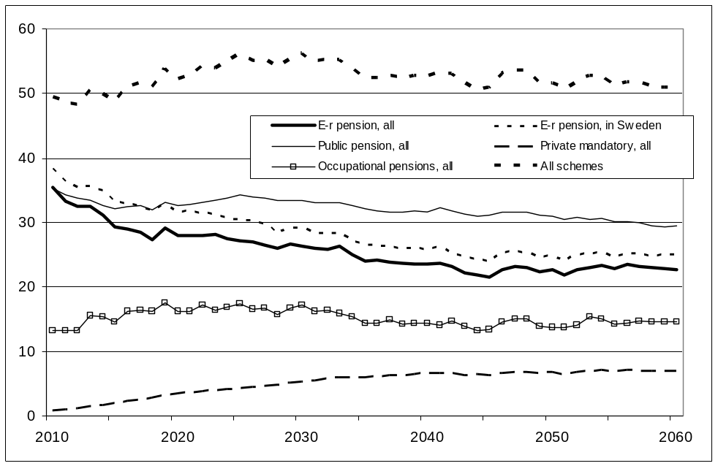

The replacement rate from the mandatory private premium pension will increase rapidly from zero to about 6-7 p.p. 2040 as the system is maturing. As the premium pension is funded and earns a market rate of return that is assumed to be higher than the income growth, the replacement rate is expected to resist the effect of the increasing longevity.
When summing up the different schemes, public and private, the aggregate replacement rate at retirement is projected to remain at the same level as today throughout the whole projection period. On the other hand, the average replacement rate from pensions for all pensioners throughout their whole life as retired is expected to fall, c.f. the benefit ratio effect in Table 5.

Contributions
Until 2060 the number of pensioners will increase by 64 %. At the same time the number of contributors will grow by 9 % and employment by 16 %. The combined effect of this is that the support ratio, i.e. the number of contributors per pensioner, will decrease from 2.3 to 1.5.
The number of pensioners substantially exceeds the number of individual’s aged 65+. This is explained by the fact that the calculations also cover individuals with Swedish pensions living abroad as well as disability pensioners and survivors younger than 65. Also the number of contributors exceed the number of employed, as contributions are paid by the central government to cover pension entitlements credited for income replacement social insurances, e.g. unemployment, sickness, disability and parental leave. Self-employed individuals are also participating in the system. The reason that the number of contributors is growing slower than the number of employees is that the number of disability pensioners is projected to decrease.

Table 7 - Number of pensioners and contributors in the Public scheme (in 1000), population over 65 and total employment (in 1000) and related ratios (%)
 | 2005 | 2010 | 2020 | 2030 | 2040 | 2050 | 2060
Number of pensioners (I) | 2 176,3 | 2 339,0 | 2 678,4 | 3 135,9 | 3 423,3 | 3 577,4 | 3 825,2
Number of people aged 65+ (II) | 1 807,8 | 1 714,9 | 2 088,1 | 2 380,6 | 2 627,6 | 2 760,7 | 3 036,7
Ratio of (I) and (II) | 1.2 | 1.4 | 1.3 | 1.3 | 1.3 | 1.3 | 1.3
Number of contributors (III) | 5 198,9 | 5 373,1 | 5 433,0 | 5 585,4 | 5 737,4 | 5 893,8 | 5 876,9
Employment(IV) | 4 336,4 | 4 536,6 | 4 884,9 | 5 003,1 | 5 129,9 | 5 236,0 | 5 246,8
Ratio of (III) and (IV) | 1.2 | 1.2 | 1.1 | 1.1 | 1.1 | 1.1 | 1.1
Support ratio (Ratio of (III) and (I)) | 2.4 | 2.3 | 2.0 | 1.8 | 1.7 | 1.6 | 1.5
Note: The support ratio is defined as a number of contributors relative to the number of pensioners in public pension schemes.

Inactivity
In order to investigate the coverage ratio and the consistency between labour force, demographic and pension's projections, the total amount of pensioners by age group have been divided by the inactive population in the same age group, i.e. the population minus labour supply in the actual age group. For the age groups below 65 the ratio falls due to decreasing disability, and for groups 65+ there will be some increase because of the growing participation among retired.
The total number of pensioners as a share of the inactive population is above 100 % for most age groups, see Table 8 and 9. One explanation to this is that the numbers include pensioners living abroad. Another reason is that pensioners that are working are counted to the labour force, even though they are receiving pension benefits at the same time. For example, if overseas pensioners are excluded the ratio in the age group 65-69 years will decreases from 127% to 118% in 2010, and from 138% to 125% in 2060. The very high and rising numbers in the age group 65-69 years is also explained by the fact that many pensioners in this age group has earnings and that work among retired is expected to become more common in the future.

Table 8 – Pensioners (all schemes) to inactive population ratio by age group (%)
 | 2005 | 2010 | 2020 | 2030 | 2040 | 2050 | 2060
Age group -54 | : | 7,9 | 4,9 | 5,3 | 5,6 | 5,5 | 5,3
Age group 55-59 | : | 108,8 | 73,7 | 88,8 | 92,0 | 97,7 | 105,1
Age group 60-64 | : | 103,6 | 87,1 | 90,8 | 94,6 | 94,9 | 94,8
Age group 65-69 | : | 127,3 | 147,2 | 144,8 | 142,9 | 142,3 | 138,3
Age group 70-74 | : | 110,5 | 117,7 | 124,3 | 117,0 | 116,4 | 119,6
Age group 75+ | : | 104,4 | 108,2 | 115,3 | 119,2 | 117,3 | 116,1
Note: Inactive population is defined as the population minus labour supply in the actual age group.

A more technical explanation to the high ratio is that the calculated numbers in table 8 and 9 are a mix of numbers originating from the exogenous AWG assumptions and endogenous numbers that are generated in the modelling. Due to somewhat different definitions between the implementation of the demographics in the model and the numbers in the assumptions, e.g. that all demographic events are occurring at the year-end in the model, and due to stochastic variation in the modelling there are some inconsistencies in the table. If the overseas pensioners are excluded thus the ratio will exceed 100% in the age group 75+, despite that no one by definition is working in this age group in the model. If the model-generated numbers for population and employment are used instead, the ratio will become very close to 100%.
The inactivity ratio for women is similar to the inactivity ratio in the population as a whole, see Table 9. However, the development in the age group 55-64 is differs - the inactivity ratio is decreasing more for women than for men. One explanation for this is that the disability rates are higher for women, and that thus the decrease in the number of female disability pensioners is projected to be more significant than for men. Another is that the number of women with widows’ pension will decrease.

Table 9 - Female pensioners to inactive population ratio by age group (%)
 | 2005 | 2010 | 2020 | 2030 | 2040 | 2050 | 2060
Age group -54 | : | 8,4 | 5,3 | 5,8 | 6,1 | 6,0 | 5,7
Age group 55-59 | : | 107,8 | 66,1 | 77,3 | 81,3 | 81,9 | 87,8
Age group 60-64 | : | 98,1 | 79,2 | 77,1 | 80,2 | 79,8 | 78,2
Age group 65-69 | : | 122,8 | 149,3 | 138,9 | 131,8 | 129,4 | 129,3
Age group 70-74 | : | 112,1 | 117,5 | 126,3 | 114,6 | 112,1 | 115,5
Age group 75+ | : | 103,3 | 108,9 | 118,9 | 122,8 | 117,7 | 114,0

New public expenditure
In Table 10 information about new earnings related pension expenditure in the public NDC system is reported. Note that new pensioners, born 1938 to 1953, also will get pension from the old DB system during the phasing in period until about 2020 (depending on at what age the individual retires).

Table 10 - Projected and disaggregated new public pension expenditure in the new Swedish NDC system
New pension | 2010 | 2020 | 2030 | 2040 | 2050 | 2060
I Projected new pension expenditure (millions EUR) | 917.9 | 1883.9 | 2873.9 | 3501.8 | 4924.9 | 6662.8
II. Average contributory period | 36.6 | 35.1 | 36.5 | 35.0 | 35.7 | 36.7
III. Monthly average pensionable earnings | 1635.8 | 3583.8 | 4909.8 | 6852.1 | 9460.6 | 13221.5
IV. Average accrual rates | 1.0 | 1.0 | 0.9 | 0.9 | 0.9 | 0.8
V. Sustainability/Adjustment factor | 1.0 | 1.0 | 1.0 | 1.0 | 1.0 | 1.0
VI. Number of new pensioners ('000) | 131.3 | 130.2 | 143.8 | 135.7 | 141.1 | 136.1
VII Average number of months paid the first year | 12.0 | 12.0 | 12.0 | 12.0 | 12.0 | 12.0
VIII. Product of II, III, IV, V, VI, VII | 885.8 | 1883.6 | 2873.9 | 3501.8 | 4924.9 | 6662.8
I-VIII | 0.0 | 0.0 | 0.0 | 0.0 | 0.0 | 0.0
Note: I-VII equals zero by definition.

Technically the base for the calculation is the accumulated pension wealth, which is the sum of “implicit pensionable earnings”, which consist of earlier credited pensionable income, pension entitlements credited for income replacement social insurances, inheritance gains and possibly reduction in case of automatic balancing. The pensionable earnings are then adjusted for the phasing in, depending on when the individual was born. There is therefore no straightforward relation between the growth of the “implicit pensionable earnings” and the average income growth. In the model computations the average number of months paid out during the first year is 12, but in real life the number is close to 6. Finally note that the method of deriving the numbers in the table makes the identity on the last row hold by definition.
Compared to the average job tenure generated by the cohort simulation model (CSM), the national calculations indicate a shorter contributory period, 39.6 years vs. 43.2 in 2060. The difference is to a large extent explained by the fact that individuals with Swedish pensions living abroad in average have a shorter career than the rest. If the overseas pensioners are excluded the average contributory period increases from 39.6 to 42.4 years. Some of the remaining difference (although hard to quantify without extensive programming) is explained by the fact that some pensioners have been living abroad during a part of their working lives, e.g. foreign immigrants or Swedish citizens returning home. In addition, stochastic variation in the modelling adds to the difference.

Assets
The Swedish pension system has accumulated a substantial buffer fund since the beginning of the 1960s. As a part of the pension reform, around 30 per cent of this fund was transferred to the central government in order to cover its extended obligations. The remainder of the fund was transformed into a buffer fund within the reformed system.
Although there is no pre-funding, the system may accumulate a buffer fund due to variations in the demographic structure of the Swedish population, if the contributions are higher than the expenditures (including administrative costs).
Also the occupational funds are projected to grow. Recently, the occupational systems have been reformed from defined benefit to defined contribution, thus accumulating substantial funds. As in the public system, there are long transitional periods, and it will take long before the systems mature.

Table 11 - Assets of pension funds and reserves (% of GDP)
 | 2005 | 2010 | 2020 | 2030 | 2040 | 2050 | 2060
Public Pension funds | 27,8 | 27,1 | 20,7 | 16,4 | 13,7 | 16,5 | 20,2
Of which liquid financial assets, non-consolidated | 5,1 | 2,2 | 2,4 | 1,9 | 1,6 | 1,9 | 2,4
Of which liquid financial assets, consolidated | 22,6 | 24,9 | 18,3 | 14,5 | 12,1 | 14,6 | 17,9
Occupational pensions | 6,1 | 6,6 | 7,1 | 7,0 | 6,7 | 6,2 | 6,5
Private pensions | 6,8 | 10,5 | 19,9 | 28,4 | 33,5 | 36,0 | 36,9
All pensions | 40,7 | 44,2 | 47,7 | 51,8 | 53,8 | 58,7 | 63,6

The private funds of the premium pension system are growing fast. As the system was fully implemented in 2003, the funds will grow as a share of GDP until 2040 when the ratio levels out round 35% of GDP. The premium pension funds are only taxed during payment, but there is administrative cost, both for the administration of the system and the mutual funds, that is charged to the funds.

2.4 Sensitivity analysis
The effects of different sensitivity tests are generally small. Calculated pension expenditures to GDP stay within a small band around the baseline scenario, fluctuating +/- 0.2 percentage points around the baseline scenario except for the higher/lower interest scenarios.

Table 12 - Public and total pension expenditures under different scenarios (deviation from the baseline)
 | 2010 | 2020 | 2030 | 2040 | 2050 | 2060
Public Pension Expenditure
Baseline | 9,6 | 9,6 | 10,1 | 10,2 | 9,9 | 10,2
Higher life expectancy | 0,0 | 0,0 | 0,0 | 0,0 | 0,1 | 0,1
Higher lab. productivity (+0.1pp.) | 0,0 | 0,0 | -0,1 | -0,1 | -0,1 | -0,1
Lower lab. productivity (-0.1pp.) | 0,0 | 0,0 | 0,0 | 0,0 | 0,0 | 0,0
Higher interest rate (+0.5 pp.) | 0,0 | -0,1 | -0,1 | -0,1 | -0,1 | -0,1
Lower interest rate (-0.5 pp.) | 0,0 | 0,0 | 0,0 | 0,0 | 0,0 | 0,0
Higher emp. rate (+1 p.p.) | 0,0 | -0,1 | -0,1 | -0,1 | -0,2 | -0,2
Higher emp. of older workers (+5 pp.) | 0,0 | -0,1 | -0,1 | -0,1 | -0,1 | -0,1
Lower migration (-10%) | 0,0 | 0,0 | 0,0 | 0,0 | 0,0 | 0,0
Total Pension Expenditure
Baseline | 11,8 | 12,6 | 13,9 | 14,4 | 14,1 | 14,9
Higher life expectancy | 0,0 | 0,0 | 0,0 | 0,1 | 0,1 | 0,1
Higher lab. productivity (+0.1pp.) | 0,0 | 0,0 | -0,1 | -0,1 | -0,2 | -0,2
Lower lab. productivity (-0.1pp.) | 0,0 | 0,0 | 0,0 | 0,1 | 0,1 | 0,1
Higher interest rate (+0.5 pp.) | 0,0 | 0,1 | 0,2 | 0,3 | 0,3 | 0,4
Lower interest rate (-0.5 pp.) | 0,0 | 0,0 | -0,1 | -0,3 | -0,4 | -0,5
Higher emp. rate (+1 p.p.) | 0,0 | -0,1 | -0,2 | -0,2 | -0,2 | -0,2
Higher emp. of older workers (+5 pp.) | 0,0 | -0,1 | -0,1 | -0,1 | -0,1 | -0,1
Lower migration (-10%) | 0,0 | 0,0 | 0,1 | 0,1 | 0,1 | 0,0

In the migration scenario the effects is very small. The reason for this is that the change in net migration is moderate, and that the smaller population result in a proportional scaling down of population, employment and production at the same pace.
The reason for the relatively big effect in the higher/lower interest rates scenarios is that premium pensions, as well as funded occupational pensions, will increase. The individual mutual funds earn a market rate of return, which means that higher interest means higher pensions. As long as the interest rate is higher than the income growth, the premium pension will grow faster than GDP. The reason for the effect on the public pensions is that less (or more) guarantee pensions will be paid out when individuals gets more (less) premium pension.
The small effects within the higher life expectancy scenario, is that public earnings-related pensions, as well as occupational and private funded pensions, are adjusted on an actuarial basis, thus compensating for the increase in the longevity. When the actuarially calculated pensions are decreasing, the top-up guarantee pension and the housing supplement will increase, thus explaining the increase in the pensions to GDP ratio.
In the higher labour productivity scenario, as well as in the higher employment scenarios, the higher income growth result in higher pensions, but they are growing at the same pace as GDP.

2.5 Description of the changes in comparison with the 2006 and 2009 projections
Compared to the 2009 projections the public pensions to GDP ratio will be somewhat higher. The change in the dependency ratio is projected to be smaller than in 2009. On the other hand the fall in the benefit ratio is projected to be less marked. The differences in the coverage ratio and the employment effect are small.

Table 13 - Average annual change in public pension expenditure to GDP during the projection period under the 2001, 2006, 2009 and 2012 projection exercises
 | Public pensions to GDP | Dependency ratio | Coverage ratio | Employment effect | Benefit ratio | Labour intensity | Residual (incl. Interaction effect)
2001 * | 1.65 | 3.85 | 0.84 | -0.48 | -2.56 | : | 0.05
2006 ** | 0.88 | 4.75 | -0.20 | -0.64 | -2.79 | : | -0.23
2009 *** | -0.13 | 5.61 | -0.37 | -0.41 | -4.32 | : | -0.63
2012 **** | 0.63 | 5.02 | -0.76 | -0.50 | -2.73 | -0.005 | -0.40
Note: * 2001-2050; ** 2004-2050; *** 2007-2060; **** 2010-2060. The Table presents the average annual change of pension expenditure and the contribution of the underlying components to that change, in analogy with Table 5 above. The components do not add up because of a residual component.

The decrease in the GDP ratio in 2050 between the projection rounds of 2006 and 2009 is to a large extent explained by the reclassification of the funded premium pension in the national accounts from the government to the private sector. The reclassification brings about a reduction of general government net lending by approximately 1 percentage point of GDP.
In Table 14 the item Change in assumptions or in the modelling is calculated residually, as no Change in the interpretation of constant policy or Policy related changes has taken place since the calculations in 2009. The changes in the assumptions include both the demographic and economic assumptions.

Table 14 - Decomposition of the difference between 2009 and the new public pension projection (% of GDP)
 | 2005 | 2010 | 2020 | 2030 | 2040 | 2050 | 2060
Ageing report 2009 | 10,0 | 9,5 | 9,4 | 9,5 | 9,4 | 9,0 | 9.4
Change in assumptions or in the modelling | 0 | 0.1 | 0.2 | 0.3 | 0.6 | 0.9 | 0.8
Improvement in the coverage | 0 | 0 | 0 | 0 | 0 | 0 | 0
Change in the interpretation of constant policy | 0 | 0 | 0 | 0 | 0 | 0 | 0
Policy related changes | 0 | 0 | 0 | 0 | 0 | 0 | 0
New projection | 10,0 | 9,6 | 9,6 | 10,1 | 10,2 | 9,9 | 10,2

3. Description of the pension projection model and its base data

3.1 Introduction
The projections have been done with the dynamic microsimulation model SESIM. The model was developed within the Swedish Ministry of Finance in close cooperation with researchers at Swedish universities. The model has then been further developed at the Ministry of Health and Social affairs. SESIM is a general microsimulation model that can be used for a broad set of analyses. The model has for example been used for analyses of health amongst elderly recently.
All the AWG projections and model simulations have been done at the Ministry of Finance at the Economic Affairs Department. No peer review has been done nationally. For outcome and medium term years the results have been validated against National accounts and calculations from The Swedish Pension Agency. The results have also been validated against the AWG demographic and macroeconomic assumptions as well as the previous round of AWG pension projections.

3.2 Overview of the model
SESIM is a mainstream dynamic microsimulation model in the sense that the variables (events) are updated in a sequence, and the period between the updating processes is a year. The starting point is 1999 and the initial sample of the Swedish population is approximately 110 000 individuals. All individuals are subject to a large number of possible events, reflecting real life phenomena, such as education, marriage, parenthood, work or retirement.
SESIM has a recursive structure, where different modules is executed in a predetermined order, see figure 3.1 below. The unit of simulation is the individual but the household also plays a significant role. Many of the simulated processes refer to household as well as individual properties. The simulation sequence starts with a set of demographic modules (mortality, adoption, migration, household formation and dissolution, disability pension, rehabilitation and regional mobility). In the next step calculations concerning education and the labour market (unemployment, employment etc.) are executed. The date of retirement is either exogenous at a fixed age or determined endogenously with a simple estimated retirement model.
Every year the individuals are assigned a status. Each individual can only have one out of nine different statuses during a specific year. Every status is related to a source of income. Employment results in earnings; retirement brings pensions etc. For employed individuals an earnings equation is used to determine the income. For other kind of statuses, for example unemployment, different rules are applied to obtain the income. After the calculation of income, a module for wealth capital income and housing is executed. Four separate assets are considered in the household portfolio: financial wealth, owned home, other real wealth and private pension savings.

Figure 1: Structure of SESIM
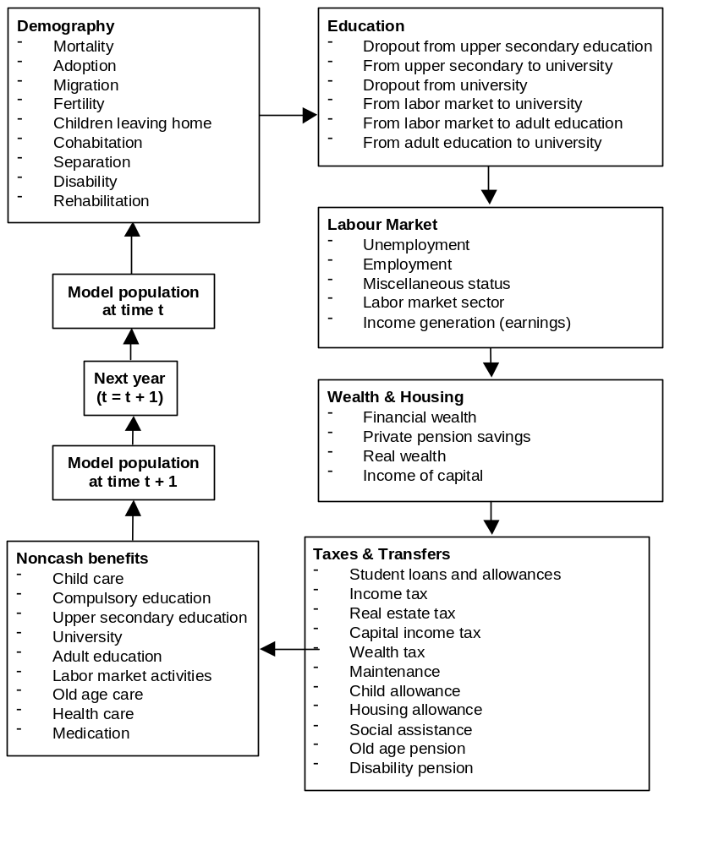

After the wealth/housing module taxes, transfer and pensions will be calculated. The rules for all three pillars of pensions have been implemented in all relevant detail (i.e. public, occupational and private pensions). All persons are assumed to claim full time pension, since the model does not handle part time retirement (mixed statuses), but can also earn work income. Also the automatic balancing mechanism is implemented in the model, but switched off in the AWG calculations, as it will not change the results in the long run.

Given the information above the household disposable income can be defined. SESIM allows for an extensive definition of income since the value of various non-cash benefits can be included, e.g. education, childcare and health care.

3.3 Data Issues
The primary database for SESIM, both for the estimation of the statistical models and for the creation of the base population, is the Statistics Sweden longitudinal database LINDA. The database is created from administrative registers and covers about 3.5 percent of the Swedish population. In 1999, the primary sample was, thus, 308 000 individuals, and including their household members the total sample size was 786 000 individuals. The selected individuals are followed over time and all relevant information is collected. Some information, for instance pension rights, can be traced back as far as to 1960. New individuals replace individuals that are omitted from the data due to death or emigration in order to maintain the statistical representativity.
As LINDA is completely created from administrative registers, no surveys are needed and, therefore, a major advantage is that there are no problems of attrition bias. The database is created by merging a large number of registers, and includes data on income and wealth, earnings, pension rights, sickness- and unemployment benefit, schooling etc. The base population used in SESIM is formed by a random draw of individuals from LINDA. Considerable work has been done with the initial dataset to make it consistent with macro outcome data, e.g. when assigning the individuals’ initial statuses.
In the construction of the base population in SESIM two main adjustments have been made:
- Adjustment of the household definition: The households in LINDA are not defined in an economically optimal sense - e.g. adults living together without being married or having common children are considered as separate households. Other data sources are therefore used to impute a more realistic family structure.
- Adding emigrants with pension rights: Individuals with Swedish pension rights will keep these entitlements even if they have emigrated. As LINDA does not include individuals living outside Sweden, information from the National Social Insurance Board regarding these individuals has been added.

Apart from the sources mentioned above, some additional data is used for estimation or imputation. The Statistics Sweden income distribution survey, HEK, which is based on interviews merged with register information is, apart from being used in the correction of the household composition, also used in the estimation of public consumptions and housing variables.

3.4 Assumptions and simulations
The most important exogenous economic macro variables in SESIM are inflation, real income growth per capita, short- and long interest rates and return on stocks. All relevant macro numbers are implemented in line with the AWG assumptions. In the calculations the model is aligned in order to achieve exogenous average unemployment and participation rates (for 5-year groups). The simulated population and labour force tracks the AWG-assumptions closely. The “raw” model results are calibrated to NA levels 2010 where possible.
All calculations are made in current prices. The indexation rules are implemented in detail in the model. Items that are price indexed by legislation, have been income indexed from 2015 in the projections (e.g. the housing allowance for pensioners and the guarantee pension). It is also assumed that the rate of return on the funded assets in the individual public DC funds and the individual occupational pension accounts will be the same for all individuals. Upon retirement it is assumed that all individuals choose to get their public DC pension benefits as a fixed annuity. The automatic balancing mechanism has been switched off in the model simulations.

4. Additional Information
- The exchange rate 9.5373 SEK/Euro, the average rate in 2010 according to Eurostat, has been used from 2010 on.
- The real interest rate, 3 percent, is used in the baseline calculations. No deduction for costs for administration of the public funds is assumed.
- Pension expenditures and public contributions are adjusted to national account levels until 2010. From 2010 on the growth rates from the model calculations are used.
- In SESIM, only occupational pensions to individuals with public pensions are calculated. Thus, different types of early retirement option programs in collective agreements, agreed disability pensions etc are not included. The numbers are not adjusted to the NA-levels, due to lack of data.
- Only the DC contributions to occupational pensions are reported, not the DB contributions that are financed by the employers on an actuarial ground.

References
- Edin, P. A. and Fredriksson, P., [2000], “LINDA – Longitudinal Individual DAta for Sweden”, Working Paper 2000:19, Uppsala University, Economics department
- Flood, L., [2003] “Formation of Wealth, income of capital and cost of housing in SESIM”, SESIM working paper (www.sesim.org)
- Flood L, Jansson F, Pettersson T, Pettersson T, Sundberg O, Westerberg A [2005] “The Handbook of SESIM – a Swedish dynamic micro simulation model” (www.sesim.org)
- Swedish Social Insurance Agency, Orange report - Annual Report of the Swedish Pension System 2010. (https://secure.pensionsmyndigheten.se/download/18.2c8f793e1335aaf986a8000282786/OR+engelsk+2010.pdf)
- Swedish Social Insurance Agency, Indexation of pensions, (www.forsakringskassan.se/pdf-broschyr/faktablad/andra_sprak/indexering_eng.pdf)
- Settergren, O., The Automatic Balance Mechanism of the Swedish Pension System1 – a non-technical introduction, Swedish National Social Insurance Agency (http://www.fk.se/sprak/eng/publications/dokument/wp_2001_2.pdf)

Appendix 1: Indexation and automatic balancing

Income indexation
The PAYG-pensions is on average indexed by wages. The system is front-loaded, though, and the pensioners receive a share of the real economic growth in advance. Technically this is achieved by calculating the annuity factor with a 1.6 per cent discount factor, resulting in a higher initial benefit than a straightforward application of the actuarial principles imply. The indexation is then reduced during the payout time by subtracting 1.6 per cent from the yearly income indexation.

The development of income is measured by the income index, which measures the change in average income for individuals active in the labour market. The income index is based on pensionable income for individuals between age 16 and 64, without any income ceiling. To avoid cyclical swings the index is calculated as a three-year moving average.

Income indexation
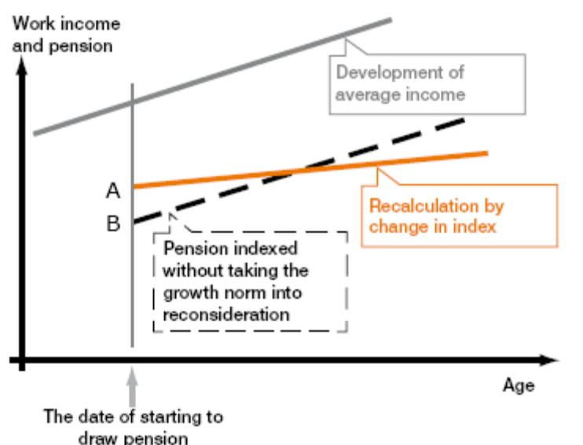

Automatic balancing
The Swedish PAYG NDC income pension system is equipped with an automatic balancing mechanism that will secure the financial stability of the system. Regardless of the demographic or economic development, the system will be able to finance its obligations with a fixed contribution rate and fixed rules for calculation of benefits. This is achieved by reducing the rate of indexing, if necessary.
If the current liabilities of the system are greater than the calculated assets the balance ratio becomes below one (1) and the balancing is activated. The balance ratio is calculated by the Swedish Social Insurance Agency, and published yearly in the pension system annual reports.
The balancing ratio is obtained by dividing the assets of the system by the pension liability. As a reaction on the financial crises that started in 2008, it was decided to implement a smoothing of the fund value in order to mitigate temporary swings in the balance ratio. If the balance ratio exceeds one (1), the assets are greater than liabilities. If the balance ratio is less than one, liabilities exceed assets, and the balancing is activated, see appendix 2 for a mathematical description of the balance ratio. When balancing is activated, pension balances and pension benefits will be indexed by the so-called balance index instead of the change in the income index.
An example: If the balance ratio falls from 1.0000 to 0.9900, while the income index rises from 100.00 to 104.00, the balance index is calculated to 102.96. The indexation of pension balances and benefits is then reduced to 2.96 instead of 4 percent.
If the balance ratio exceeds 1.0000 during a period when balancing is activated, pension balances and benefits will be indexed at a rate higher than the increase in the income index. When the level of the balance index reaches the level of the income index, the balancing is deactivated and the system returns to indexation by the normal income index.

Income and Balance indexation
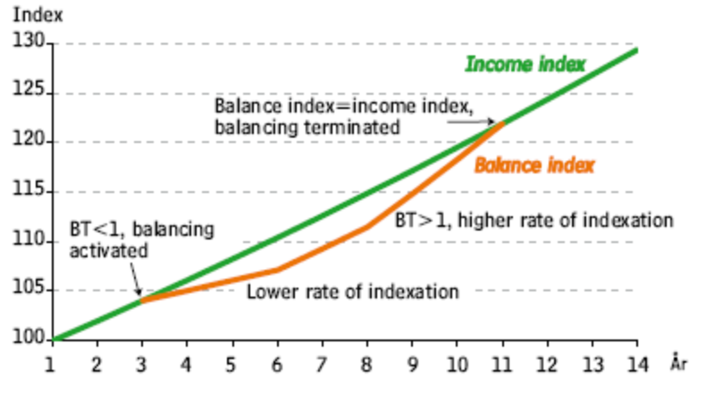

Appendix 2: Mathematical Description of the Balance Ratio

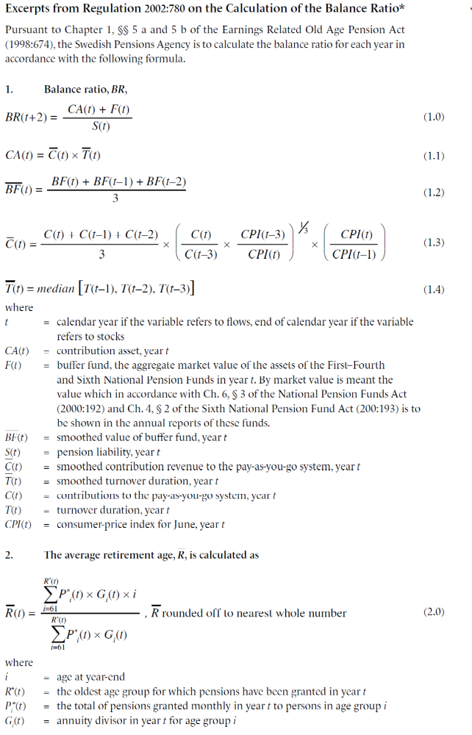
* Some editing has been done to simplify the presentation
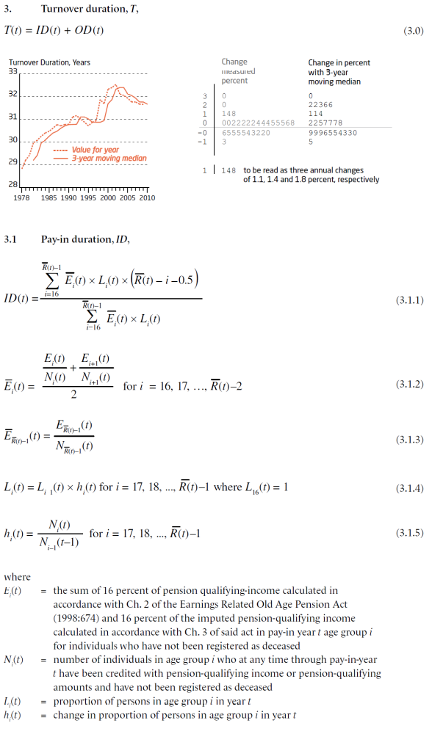
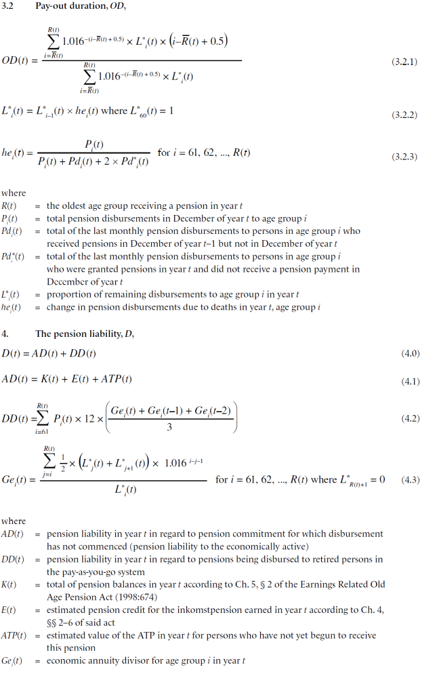

That is classified as a private pension in National Accounts terms.
The income base amount 2011 is SEK 52 100 and is indexed yearly with change of average earnings. The public pension ceiling is about SEK 390 750 or approx EUR 41 000.
(0.07+0.1021)/(1-0.07) = 0.185
The gender-neutral annuity divisors in the NDC system result in about 8% higher pension for women (at age 65) compared to a system based on sex specific life expectancy.
See appendix 1 for more details.
The activation of the balancing mechanism is based on the pension system annual reports that are published by the Swedish Pensions Agency. There are plans to implement legislation for redistribution of pension fees if the PAYG system becomes over-consolidated, but nothing has been decided this far. More information about the automatic balancing can be found appendix 1.
E.g. a person with 39 years of residence achieves 39/40-parts of the full benefit.
In the AWG calculations income indexations is assumed from 2015 though.
The price base amount 2011 is SEK 42 800, and is indexed by the change of the consumer price index. The assumed exchange rate from 2010 on is SEK 9.5373 per EURO.
Common thresholds, common administration etc.
BTP amounts to maximum 93% of housing costs up to SEK 5 000 a month (EUR 520) for single persons and 2500 (EUR 260) for couples.
Average age for persons leaving the work force, working at age 50, including disability pensioners. The average age for withdrawal of public pension was 64.7 years 2010. Source: The Swedish Pensions Agency.
Survivors as well as disability pensions are fully income indexed in the AWG calculations.
The occupational systems have been renegotiated in line with the new public pension system, towards more defined contribution and less defined benefit. As in the public system, there are long transitional periods.
Due to a decision from Eurostat, the premium pension has been reclassified from 2007 as belonging to the private sector rather than to general government. The reclassification brings about a reduction of general government net lending by approximately 1 percentage point of GDP, as measured by the European system of national accounts (ESA 95).
12 000 SEK plus 35 percent of business income not exceeding 10 PBA:s.
No results for voluntary private pension saving will be reported in the AWG calculations due to technical problems.
The SESIM model has not been updated with the latest tax reforms, thus net pensions will be somewhat underestimated.
Actually, by law some thresholds in these systems are not “mechanically” indexed at all. In the calculations the housing cost is price indexed, and consequently the development of the Housing supplement for pensioners is quite limited throughout the projection period.
Unlike the previous round of AWG calculations private pension savings is not included this time for technical reasons. In ESSPROS the housing subsidy is counted as a benefit in kind (function 7 housing), but practically this is a cash benefit that is a closely integrated part of the pension system. The benefit is not counted in any other item in the AWG calculations.
The reasons to the differences between Statistics Sweden and Eurostat is not primarily a question for AWG, but might be explained by use of different data revisions.
The voluntary private pensions are not computed for technical reasons. The likely development, though, is that the GDP ratio will decrease, as the thresholds are price indexed and changes in the tax system that makes this type of pension savings less favourable.
The SESIM model has not been updated with the latest tax reforms, thus net pensions will be somewhat underestimated.
No effect of the improved incentives especially 65+ to work more and prolong their working lives is assumed in the AWG calculations.
In the modelling the very complicated rules are simplified. All amounts are income indexed.
The replacement rate is defined as the first pension of those who retire a given year compared to the economy-wide average wage for individual’s aged 60-64 years the same year.
The effect on the replacement rate for Private voluntary pensions, for individuals who have it, is high, compared to the effect on the benefit ratio. This is explained by the fact that most recipients choose to get the saving paid out during a 5-year period. After this period the replacement ratio will be substantially lower.
Individual pension rights in the premium pension system have been credited since 1995 for individuals born after 1937.
Due to technical problems no it is not possible to report the funds of the voluntary private pension savings.
Documentation that is more detailed can be found in Flood et.al [2005], or at www.sesim.org.
The future need for care - Results from the LEV project, Ministry of Health and Social Affairs, 2010.
If necessary the sample can be extended.
In these calculations the pension decision is endogenously determined, although the average effective retirement age is aligned to track the AWG labour market assumptions.
The different statuses are: Child (0-15 years old), Old-age pension, Student, Disability pension, Parental leave, Unemployed, Employed, Miscellaneous, Emigrated (individuals living abroad with Swedish pensions rights).
There are currently problems with the voluntary private pension savings though, and the module has to be re-estimated.
Regional mobility and tenure choice is based on a database named GEOSWEDE. The Statistics Sweden household expenditure survey (Level of Living Survey) is used for calculation of indirect taxation. The health and care modules are based on the Kungsholmen study by Mårten Lagergren and Statistics Sweden,

